Remote App Design

Aim: Design a user-friendly remote app for controlling smart devices from a smartphone.

Procedure:

1. Define features like device control and customization.

2. Create rough sketches of app screens. Start a new project in Figma and set up frames for main screens. Design the app’s visual elements and controls.

3. Use Figma’s prototyping tools to simulate user actions.

4. Share the prototype with users for feedback. Adjust based on feedback to improve usability.

5. Finalize the design with polished visuals. Prepare design assets for development. Create design documentation in Figma.

Result: The app will have a clean, intuitive interface, and user feedback will ensure it meets practical needs and functions smoothly.

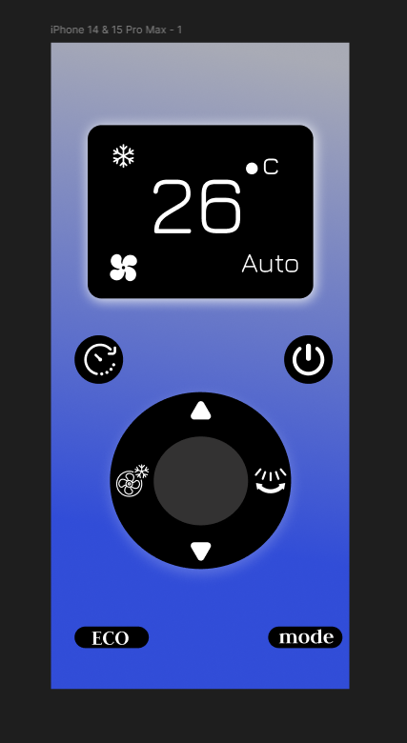

Hobby Management App Design

Aim: Create an app for managing hobbies, tracking progress, and connecting with others.

Procedure:

1. Determine key features like tracking and social sharing.
2. Sketch initial layouts for main screens. Create frames for different app sections in Figma.
3. Design visual elements and layouts. Link screens to simulate user flow. Gather feedback on design and functionality.
4. Make improvements based on user feedback.
5. Add animations or transitions if needed. Prepare assets for development.
6. Detail design decisions and user flow in Figma.

Result: The app will provide effective hobby management and social features, with a user-friendly interface refined through feedback.

